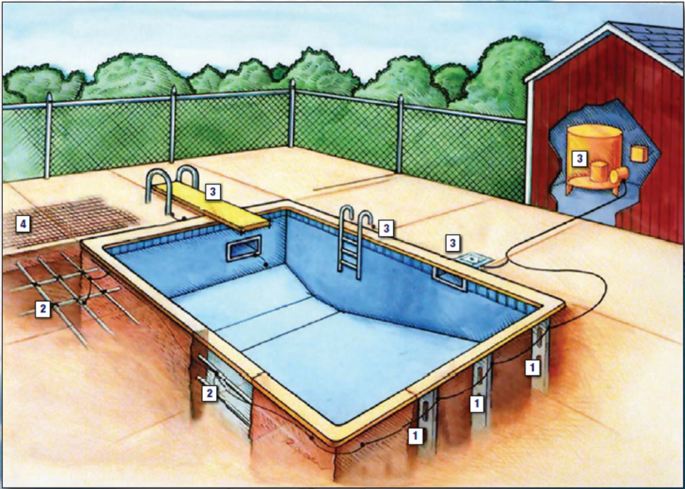
¹ Bonding of pool shell
² Bonding of rebar
³ Bonding of ladders, diving board, lights, skimmers, and pool equipment
⁴ Grounding mat

SECTION E4204 BONDING
E4204.1 Performance. The equipotential bonding required by this section shall be installed to reduce voltage gradients in the pool area as prescribed.
E4204.2 Bonded parts. The parts of pools, spas, and hot tubs specified in Items 1 through 7 shall be bonded together using insulated, covered or bare solid copper conductors not smaller than 8 AWG or using rigid metal conduit of brass or other identified corrosion-resistant metal. An 8 AWG or larger solid copper bonding conductor provided to reduce voltage gradients in the pool, spa, or hot tub area shall not be required to be extended or attached to remote panelboards, service equipment, or electrodes. Connections shall be made by exothermic welding or by listed pressure connectors or clamps that are labeled as being suitable for the purpose and that are made of stainless steel, brass, copper or copper alloy. Connection devices or fittings that depend solely on solder shall not be used. Sheet metal screws shall not be used to connect bonding conductors or connection devices:
1. Conductive pool shells. Bonding to conductive pool shells shall be provided as specified in Item 1.1 or 1.2. Poured concrete, pneumatically applied or sprayed concrete, and concrete block with painted or plastered coatings shall be considered to be conductive materials because of their water permeability and porosity. Vinyl liners and fiberglass composite shells shall be considered to be nonconductive materials.
1.1. Structural Reinforcing Steel. Unencapsulated structural reinforcing steel shall be bonded together by steel tie wires or the equivalent. Where structural reinforcing steel is encapsulated in a nonconductive compound, a copper conductor grid shall be installed in accordance with Item 1.2.
1.2. Copper Conductor Grid. A copper conductor grid shall be provided and shall comply with Items 1.2.1 through 1.2.4:
1.2.1. It shall be constructed of minimum 8 AWG bare solid copper conductors bonded to each other at all points of crossing.
1.2.2. It shall conform to the contour of the pool and the pool deck.
1.2.3. It shall be arranged in a 12 inch (305 mm) by 12 inch (305 mm) network of conductors in a uniformly spaced perpendicular grid pattern with a tolerance of 4 inches (102 mm).
1.2.4. It shall be secured within or under the pool not more than 6 inches (152 mm) from the outer contour of the pool shell.
2. Perimeter surfaces. The perimeter surface shall extend for 3 feet (914 mm) horizontally beyond the inside walls of the pool and shall include unpaved surfaces, poured concrete and other types of paving. Bonding to perimeter surfaces shall be provided as specified in Item 2.1 or 2.2 and shall be attached to the pool, spa, or hot tub reinforcing steel or copper conductor grid at a minimum of four points uniformly spaced around the perimeter of the pool, spa, or hot tub. For nonconductive pool shells, bonding at four points shall not be required.
2.1. Structural Reinforcing Steel. Structural reinforcing steel shall be bonded in accordance with Item 1.1.
2.2. Alternate Means. Where structural reinforcing steel is not available or is encapsulated in a nonconductive compound, a copper conductor(s) shall be used in accordance with Items 2.2.1 through 2.2.5:
2.2.1. At least one minimum 8 AWG bare solid copper conductor shall be provided.
2.2.2. The conductors shall follow the contour of the perimeter surface.
2.2.3. Splices shall be listed.
2.2.4. The required conductor shall be 18 to 24 inches (457 to 610 mm) from the inside walls of the pool.
2.2.5. The required conductor shall be secured within or under the perimeter surface 4 to 6 inches (102 mm to 152 mm) below the subgrade.
3. Metallic components. All metallic parts of the pool structure, including reinforcing metal not addressed in Item 1.1, shall be bonded. Where reinforcing steel is encapsulated with a nonconductive compound, the reinforcing steel shall not be required to be bonded.
4. Underwater lighting. All metal forming shells and mounting brackets of no-niche luminaires shall be bonded.
Exception: Listed low-voltage lighting systems with nonmetallic forming shells shall not require bonding.
5. Metal fittings. All metal fittings within or attached to the pool structure shall be bonded. Isolated parts that are not over 4 inches (102 mm) in any dimension and do not penetrate into the pool structure more than 1 inch (25.4 mm) shall not require bonding.
6. Electrical equipment. Metal parts of electrical equipment associated with the pool water circulating system, including pump motors and metal parts of equipment associated with pool covers, including electric motors, shall be bonded.
Exception: Metal parts of listed equipment incorporating an approved system of double insulation shall not be bonded.
6.1. Double-Insulated Water Pump Motors. Where a double-insulated water pump motor is installed under the provisions of this item, a solid 8 AWG copper conductor of sufficient length to make a bonding connection to a replacement motor shall be extended from the bonding grid to an accessible point in the vicinity of the pool pump motor. Where there is no connection between the swimming pool bonding grid and the equipment grounding system for the premises, this bonding conductor shall be connected to the equipment grounding conductor of the motor circuit.
6.2. Pool Water Heaters. For pool water heaters rated at more than 50 amperes and having specific instructions regarding bonding and grounding, only those parts designated to be bonded shall be bonded and only those parts designated to be grounded shall be grounded.
7. Metal wiring methods and equipment. Metal-sheathed cables and raceways, metal piping, and all fixed metal parts shall be bonded.
Exceptions:
1. Those separated from the pool by a permanent barrier shall not be required to be bonded.
2. Those greater than 5 feet (1524 mm) horizontally from the inside walls of the pool shall not be required to be bonded.

3. Those greater than 12 feet (3658 mm) measured vertically above the maximum water level of the pool, or as measured vertically above any observation stands, towers, or platforms, or any diving structures, shall not be required to be bonded.
E4204.3 Pool water. The pool water shall be intentionally bonded by means of a conductive surface area not less than 9 square inches (5806 mm²) installed in contact with the pool water. This bond shall be permitted to consist of parts that are required to be bonded in Section E4204.2.

